**Course Project**

**AEE-4263-E1 Space Flight Mechanics**

**Dr. Markus Wilde**

**Archit Bindi Darpan Kittiwin Murtaza**

**Trip to Ganymede**

# Abstract

Summaries this report in 1 neat paragraph.

Contents

Abstract 2

Introduction 4

Approach 5

Heliocentric Trajectory 6

Planet Centric trajectory & B-Plane targeting 7

Mission Timeline 8

Mass Budget 9

Conclusion 10

Appendix 11

References 12

# Introduction

Must include:

* Previous missions with similar trajectory. Their masses, trajectories, fly-by, mission duration.
* 5 properly cited sources for each covered mission
* Accepted references conference papers, journals, papers & books.
* Use the GoogleDoc for supporting research
* About 1.5 - 2 pages

# Approach

This must include:

* Mission analyses
* All assumptions clearly stated (In addition to those that are given in Section 2)
* All Look-up values used in the code
* Formulas that are used in the code with variables clearly explained (Include a **nomenclature** **table** for ease)
* No calculations
* Thought process on how we came up with the final trajectory. Should talk about different scenarios we tested to get optimum values.

# Heliocentric Trajectory

This includes:

* Heliocentric mission trajectory with the following details:

1. Place Sun at (0,0)
2. Must have Earth on +x-axis
3. Orbit plotted for every planet our spacecraft crosses
4. Axis labels
5. Title
6. Planets labeled

The graph below shows the heliocentric trajectory of the spacecraft on its way to Ganymede. The green trajectory is the first transfer ellipse on which the spacecraft leaves Earth’s SOI at a true anomaly of 0° and enters Mars’ SOI at a true anomaly of 85°. The spacecraft then leaves Mars SOI on a second transfer ellipse with a true anomaly of 73.1° and arrives at Jupiter’s SOI at a true anomaly of 179.9°.

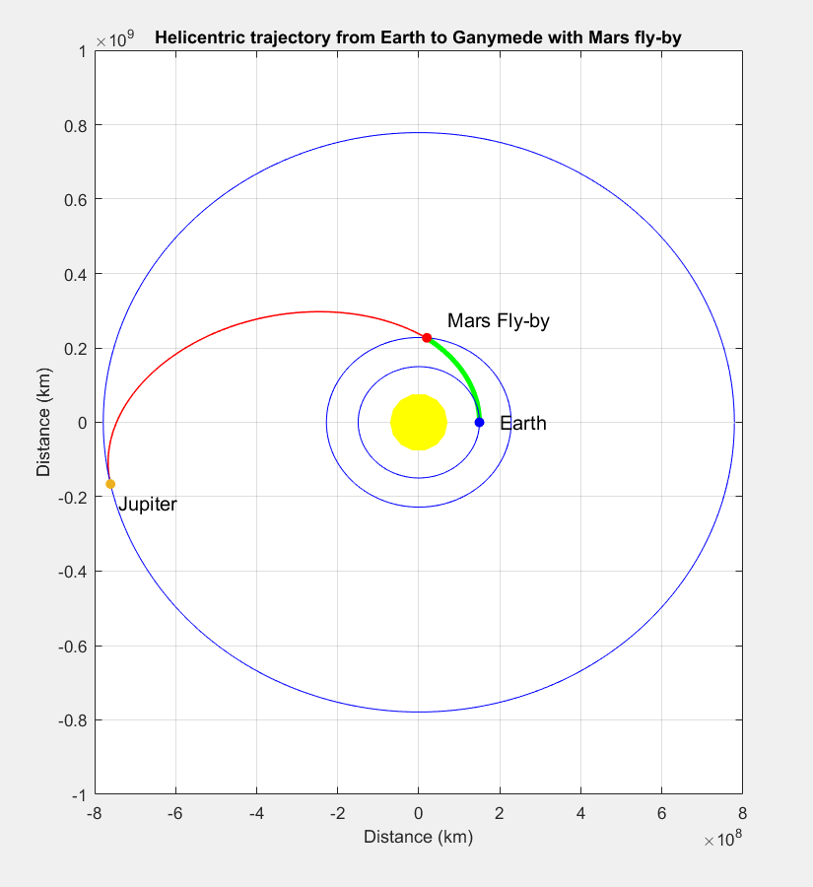

Figure 1 – Heliocentric Trajectory of Spacecraft

# Planet Centric trajectory & B-Plane targeting

This requires graphs for:

* Earth departure and its SOI
* Mars SOI showing flyby
* Jupiter arrival within it’s SOI
* Ganymede SOI arrival
* B-plane targeting graphs with no trajectory. Just have to plot target point & the size of the planet for reference. No need to account for any targeting error.

NOTE: each of these plots are **Planet-centric** so place the planet on (0,0) for ease of plotting

The following plots show the planet centric trajectories of the spacecraft as it leaves Earth’s sphere of influence (SOI) on a heliocentric transfer ellipse, performs a Mars fly-by, then enters Jupiter’s SOI to perform a fly-by with Callisto, and finally arrives in Ganymede’s SOI and inserts itself into a circular orbit around it.

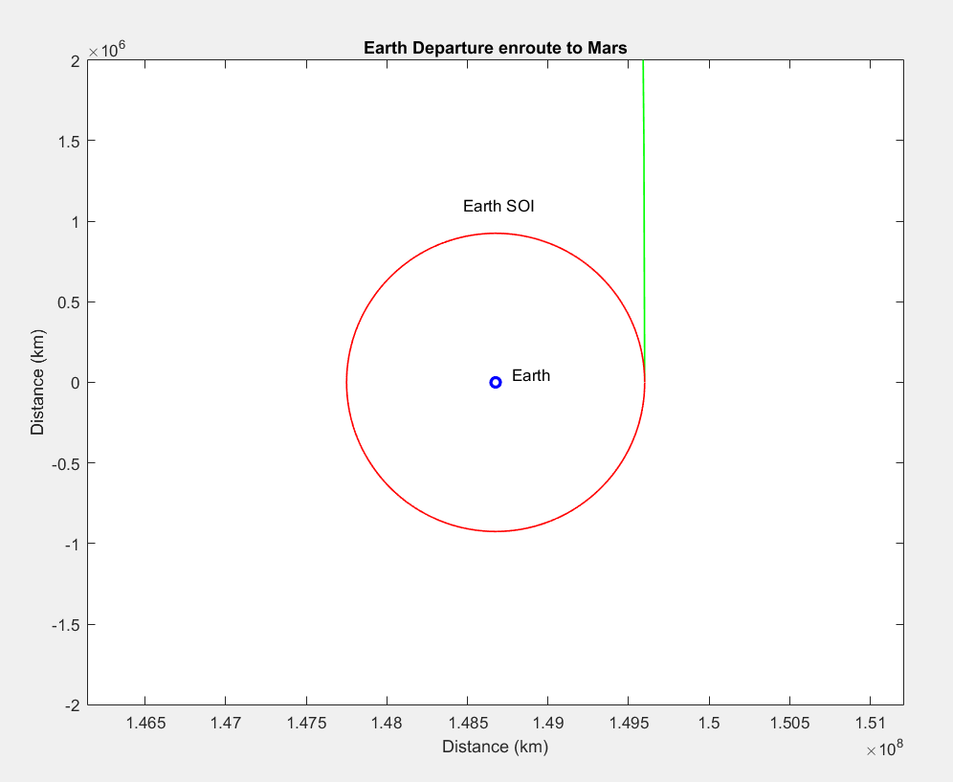

Figure 2 – Earth Departure and its SOI

The following plot shows the Mars fly-by trajectory in which the hyperbolic periareum is at an altitude of 110 km.

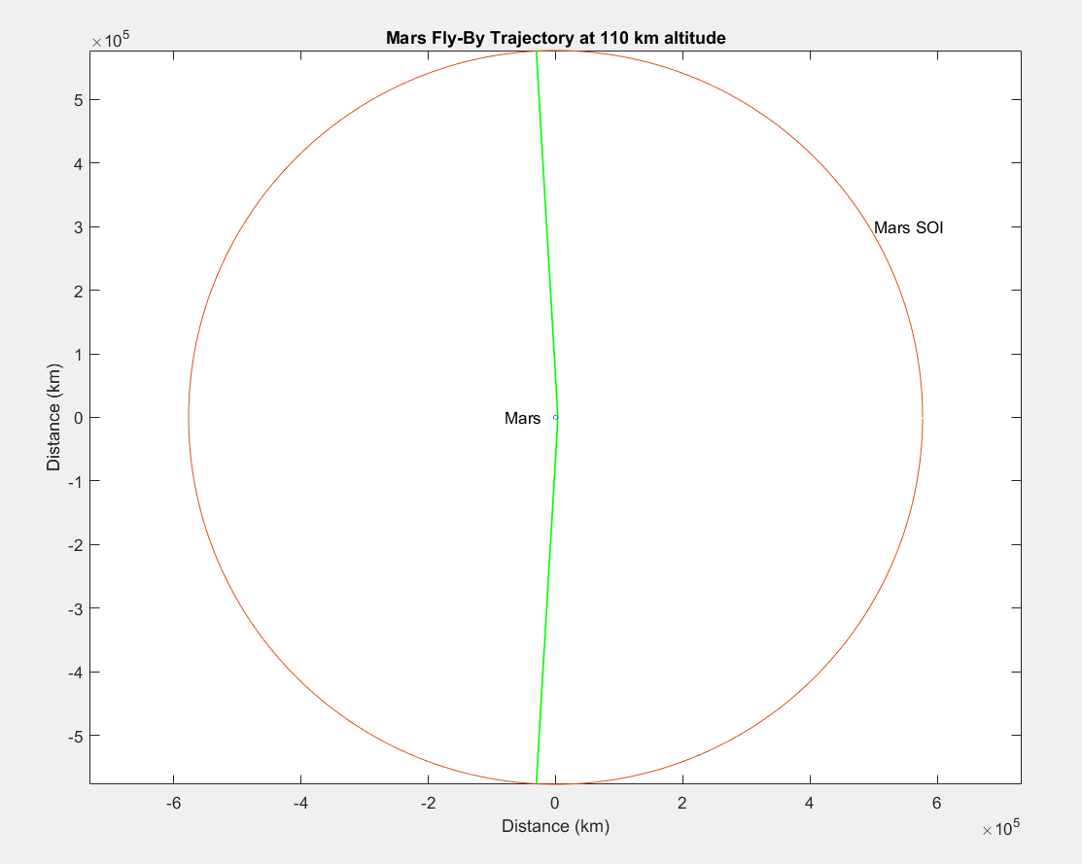

Figure 3 - Mars SOI showing flyby

The plots below show the trajectory of the spacecraft as it enters Jupiter’s SOI. Inside the SOI the spacecraft performs a fly-by with Callisto and then arrives at Ganymede.

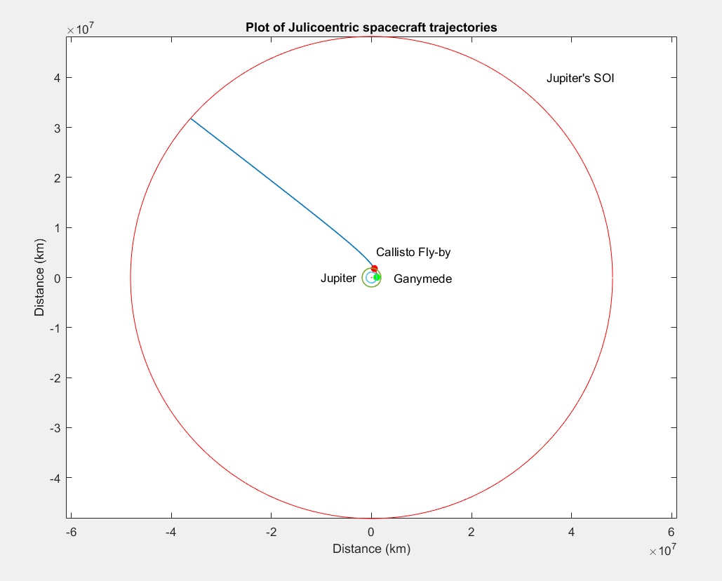

Figure 4- Jupiter Arrival and SOI

Below is a close-up view of the Juliocentric trajectory of the spacecraft inside Jupiter’s SOI.

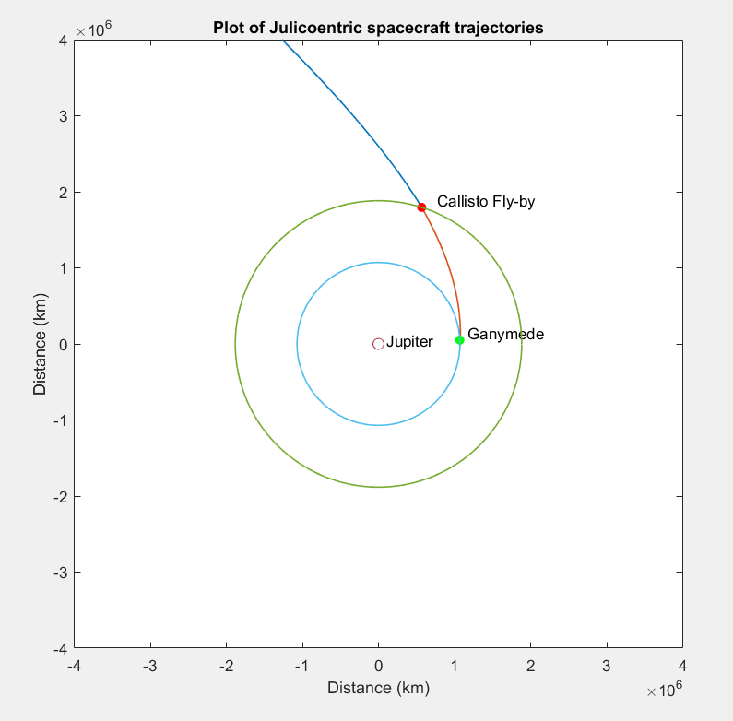

Figure 5 - Juliocentric Trajectory (Note: Jupiter’s SOI has not been drawn because it is so large that the details above are reduced to small dots in the screen)

The spacecraft trajectory during Callisto fly-by is illustrated in the figure below. The periapse of the hyperbolic fly-by trajectory is at an altitude of 625 km.

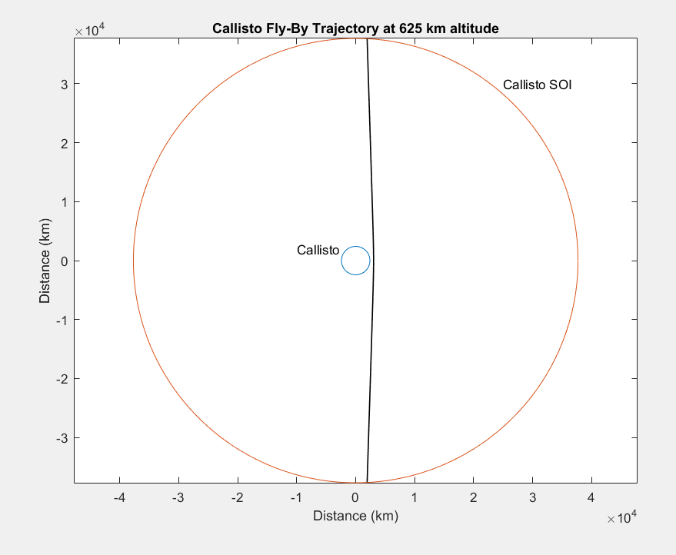

Figure 6- Callisto Fly-by maneuver

Finally the spacecraft arrives inside Ganymede’s sphere of influence on a hyperbola and inserts itself into a circular mission orbit with an altitude of 200 km.

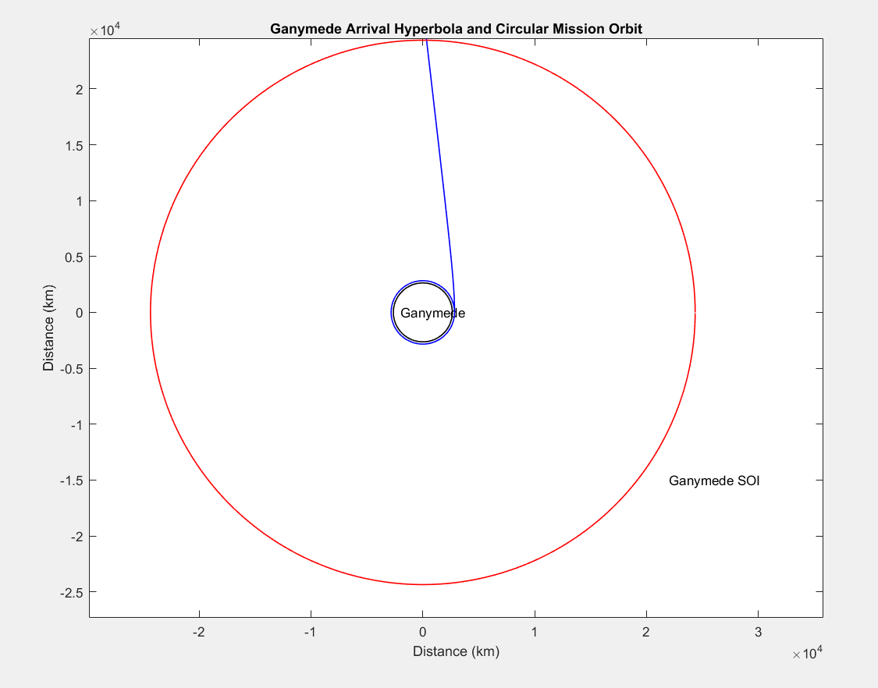

Figure 7 – Ganymede Arrival and insertion into circular mission orbit

# Mission Timeline

Deliver a tabulated timeline for entire mission:

|  |  |  |  |
| --- | --- | --- | --- |
|  | Time t | Position |  |
|  | 0 | At earth departure | STARTING POSITION |
|  | 0 | Earth SOI |  |
|  | … | … |  |
| TOTAL MISSION TIME | … | Orbit around Ganymede | FINAL POSITION |

NOTE: Time spent inside any SOI is assumed to be 0 i.e. instantaneous flyby. However, time needs to be accounted for once we get into Jupiter’s SOI, followed by Ganymede arrival.

# Mass Budget

Give a tabulated mass budget for the entire mission. **Please read Section 3.3.6 for all the required details that must be included in this table.** Total & final mass of spacecraft at each burn is required.

# Conclusion

A well-articulated, short conclusion which gives remarks, comparison of our mission to previous/future missions, potential-weakness & strengths, something that might need to be improved for a scalable future mission.

# Appendix

Entire MATLAB code goes here. Ensure it is commented, sectioned & has sensible layout.

# References